###### Write a Java program to convert a given integer (in seconds) to hours, minutes and seconds.

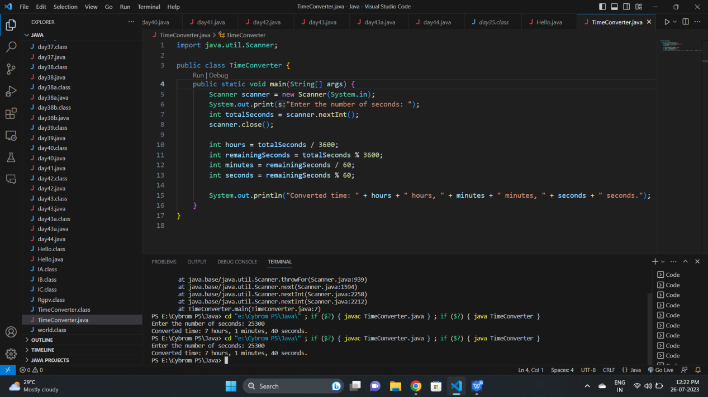

##### Write a java program to convert a given integer (in days) to years, months and days, assumes that all months have 30 days and all years have 365 days.

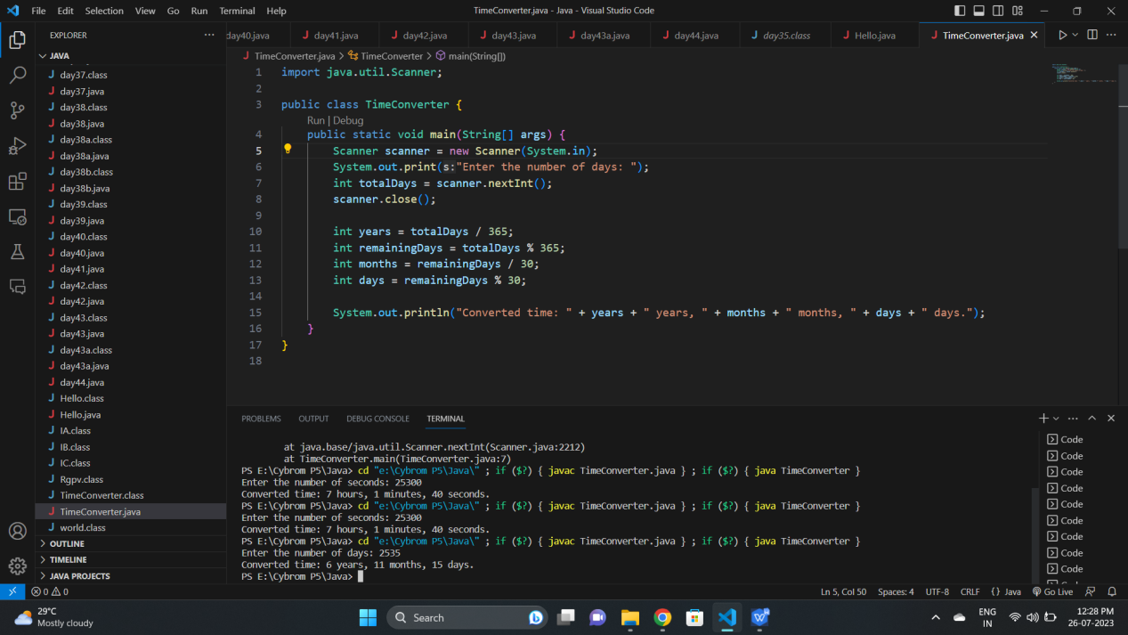

Q3. Write a java program that read 5 numbers and sum of all odd values between them

#### Screenshot (26)

###### Q4. Write a Java program that reads two integers and checks whether they are multiplied or not.

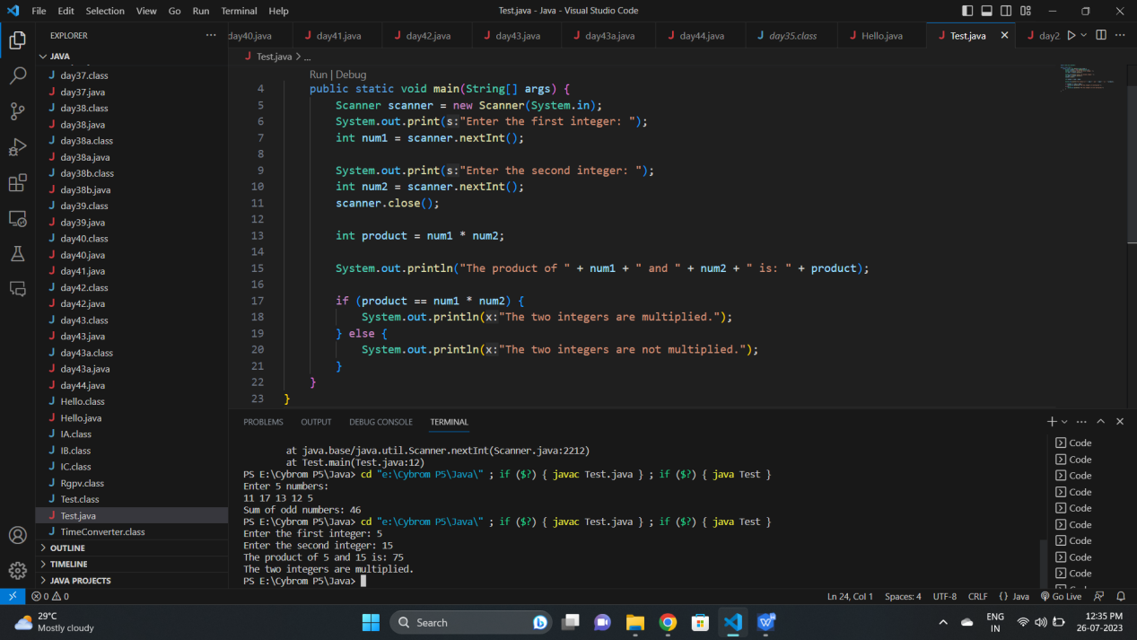

###### Write a Java program that reads an integer between 1 and 12 and print the month of the year in English.

###### Screenshot (28)

###### 6. Write a java program that read 5 numbers and counts the number of positive

###### numbers and negative numbers.

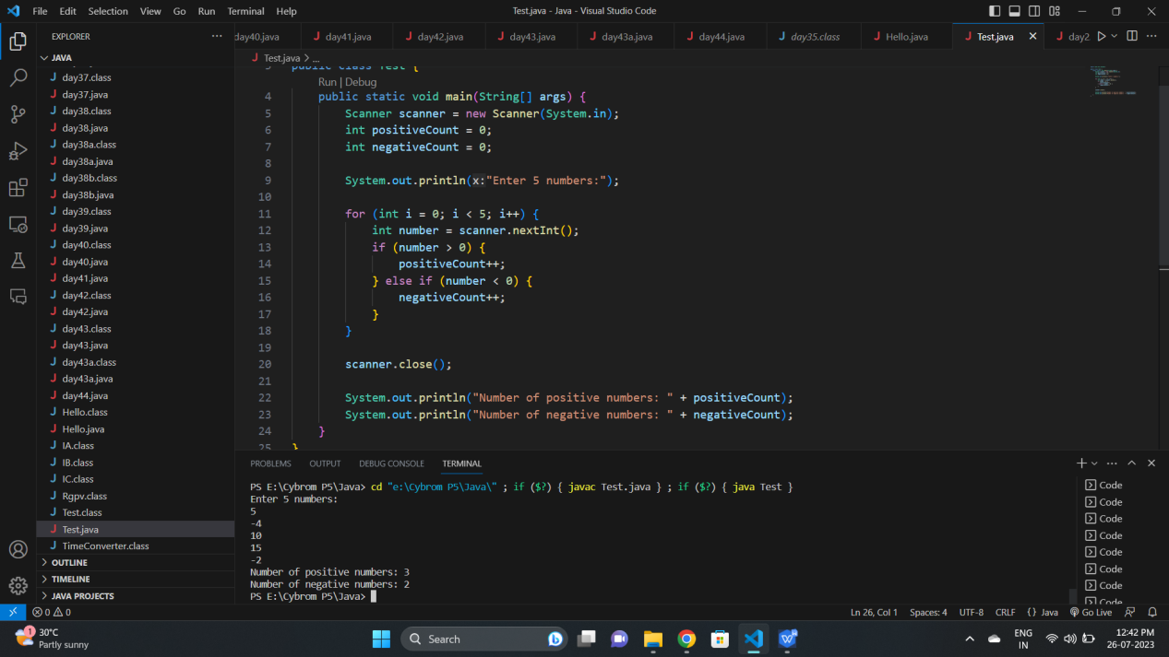

###### 7. Write a java program that read 5 numbers and counts the number of positive

###### numbers and print the average of all positive values.

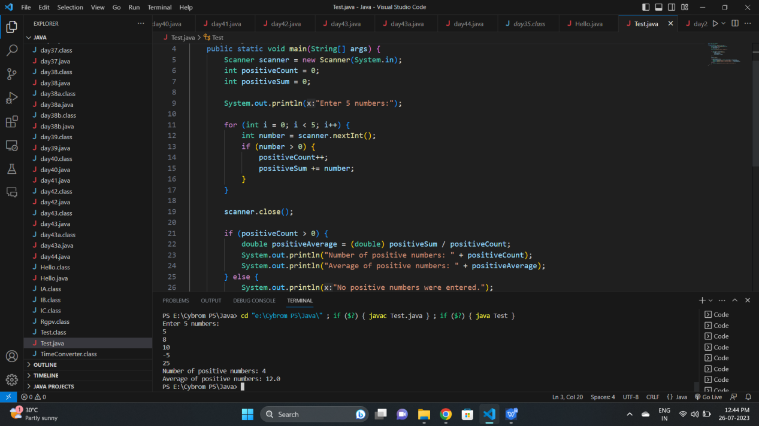

###### 8. Write a java program that read 5 numbers and sum of all odd values

###### between them.

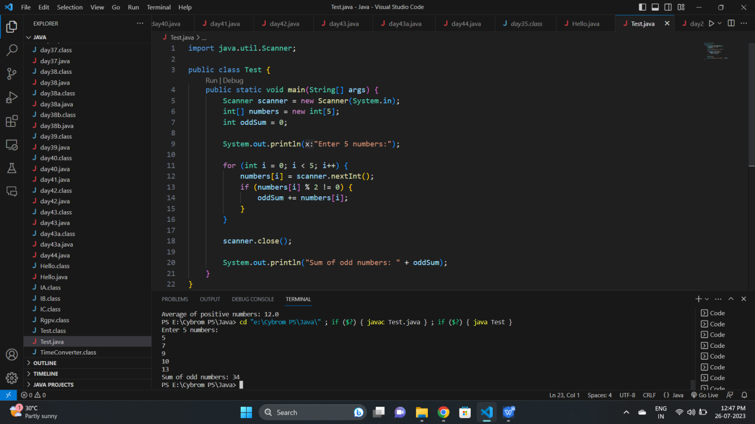

###### Q9. Write java program that converts Centigrade to Fahrenheit.

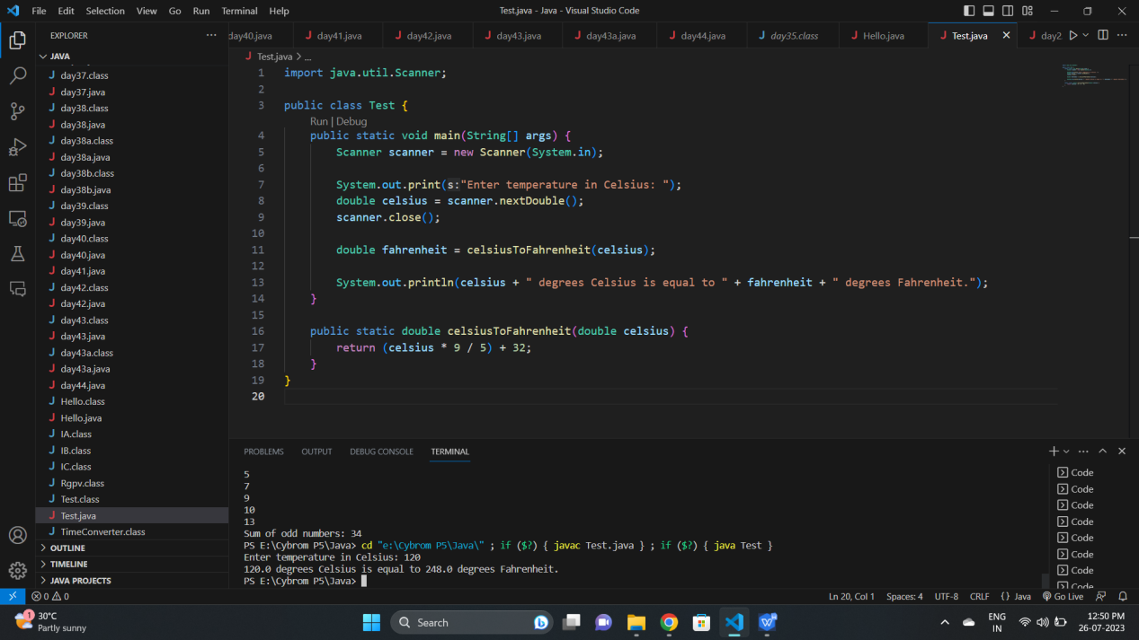

###### Write a java program that converts kilometers per hour to miles per hour

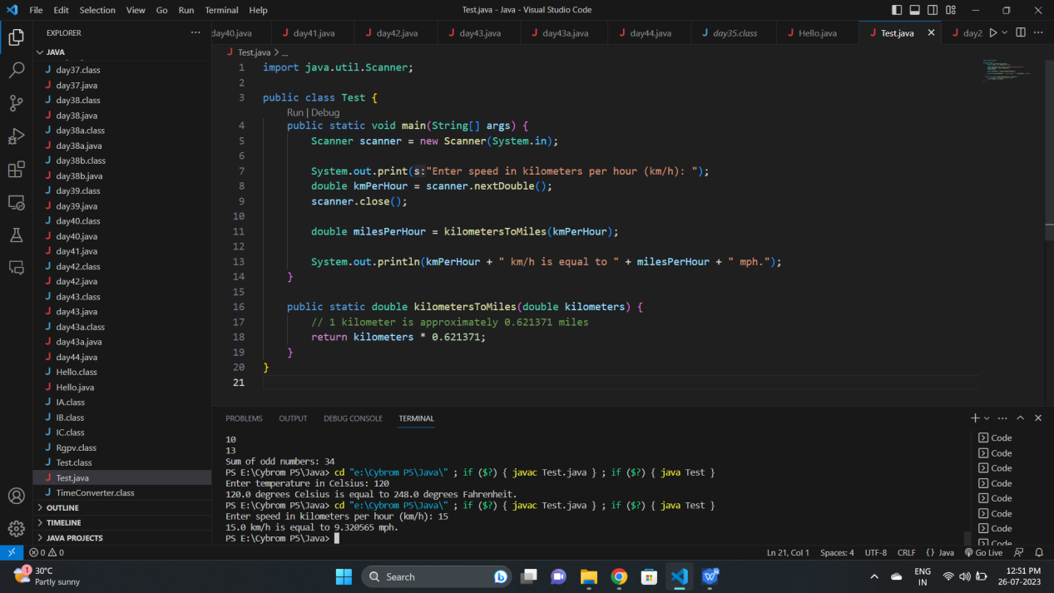

###### Q11. Write a java program to check two given integers, and print true if one of

###### them is 30 or if their sum is 30 else print false

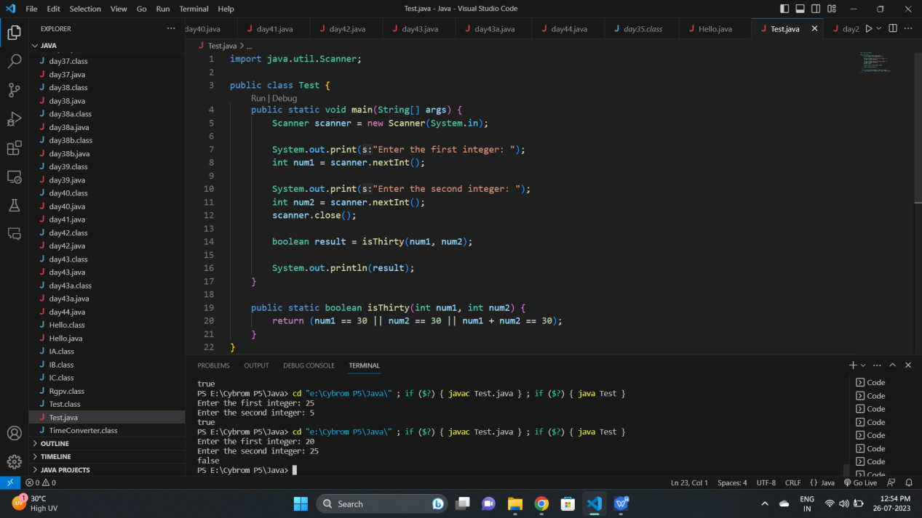

###### Q13. Write a java program to integral quotient and remainder of a division

